**Final Project Report**

Student Name: Jung Juhui

Student ID: 2020315701

**1. Briefly describe the project purpose:**

The project is for booking movie. If you are a member of this website you can log in or if not you can sign up. If you sign up and log in successfully, you can check the list of current showing movies and information about them, buy movie tickets and check the list of movies you reserved.

**2. Draw the logic flow of the program (with flowchart):**

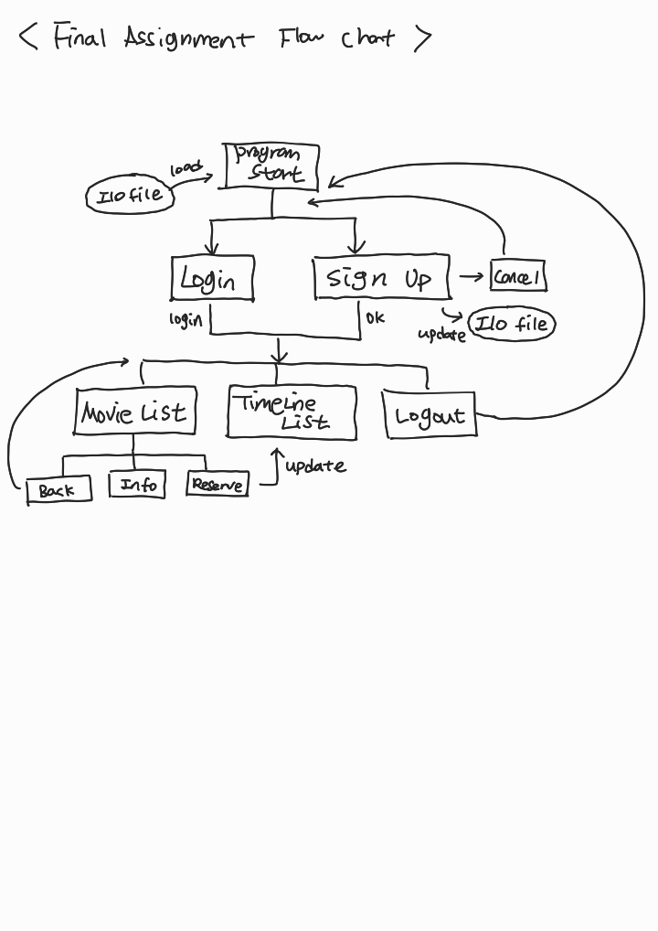

**3. Provide screenshots for each screen with brief description:**

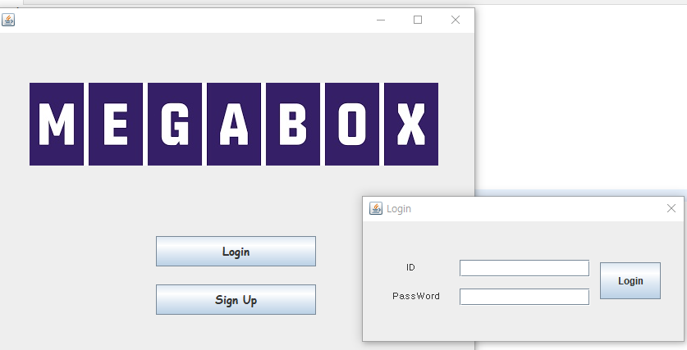

< Login>

This screen is for login. When the program is executed, you can see the screen on the left side. You can either click login or sign up. Right side window is for login. If you are already a member you can successfully login. But if you are not below error 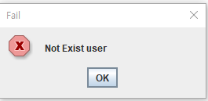message will be shown.

Or if you put right id but forget the password, below error message will be shown.

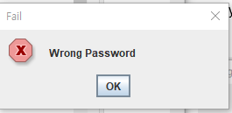

----------------------------------------------------------------------------------------------------------------

< Sign Up >

You can also join the booking site and become a member by clicking 'Sign Up' button.

If you click the button, you can see the window above.

There is specific format for each id, pw, name, birth. If you don't follow the format, error messages will be shown and let you know which error you made.

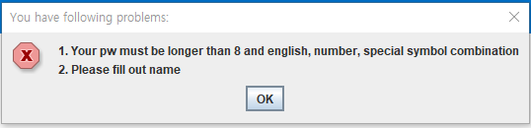

If you sign up successfully, the text file in the java project will be updated.

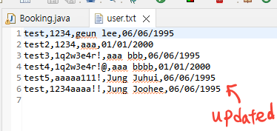

Now we are done with login and sign up. As soon as you sign up well, you will be logged in automatically. And it will show the window below.

----------------------------------------------------------------------------------------------------------------

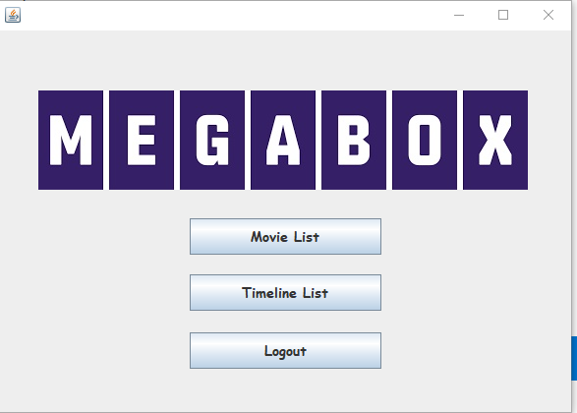

This window is key section of my program.  
First, if you click Movie List, below will be shown.

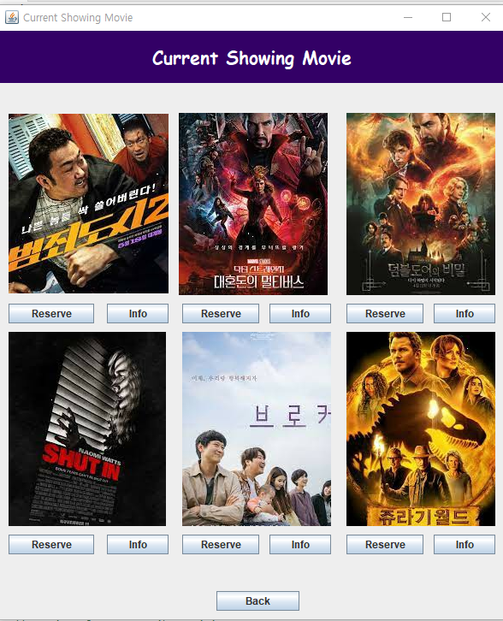

< Movie List >

You can find out which movies are currently showing and look for some information about the movie by clicking 'Info' button.

----------------------------------------------------------------------------------------------------------------

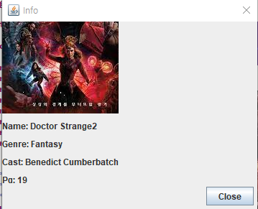.

< Info >

You can find out some information in this window. You can check the name, henre, cast, pg of each movie and it will help you choose the movie that you want to watch.

----------------------------------------------------------------------------------------------------------------

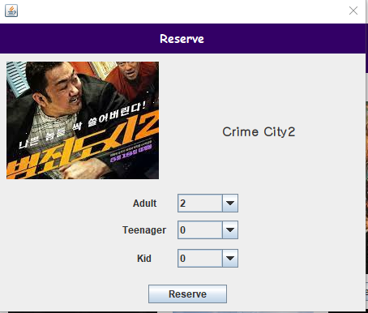

< Reserve >

Also, you can actually buy some tickets by clicking the reserve button.

You can choose tickets for adult, teenager, kid ticket and each price is different.  
If you click reserve button sucess message will be popped up. And Buy list will be updated.

If you want to find buy list you can go back by clicking 'Back' button in 'Movie List' window. And click 'Timeline List' button.





----------------------------------------------------------------------------------------------------------------

If you click Timeline List, you can see the window below.

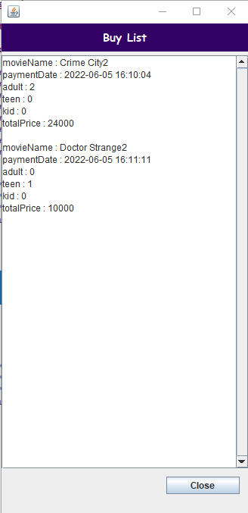

< Timeline List >

This is timeline list (what i mentioned buy list). You can see some information about purchase history. And by using multi threads, you can check the lists with a time difference.

And finally, you can also logout by clicking 'Logout' button.

**4. Explain the code of the main functionalities**

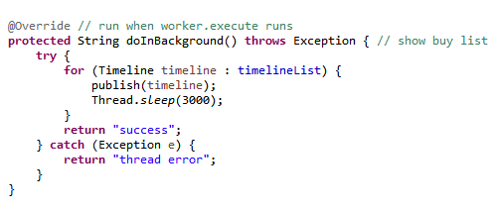

< in TimelineList >

It can be executed in multiple threads and it can give pause when the buy list is shown.

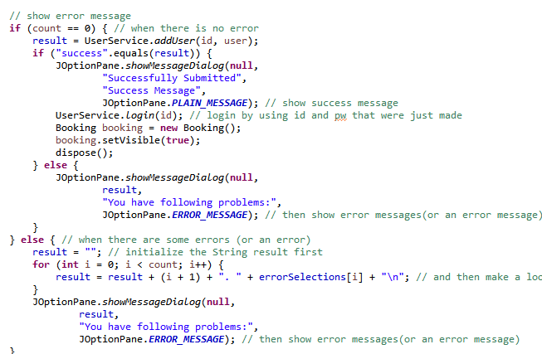

< in SignUp >

It can find out if there is an error when you are trying to sign up. If you successfully sign up it gives success message or if not it gives error messages.

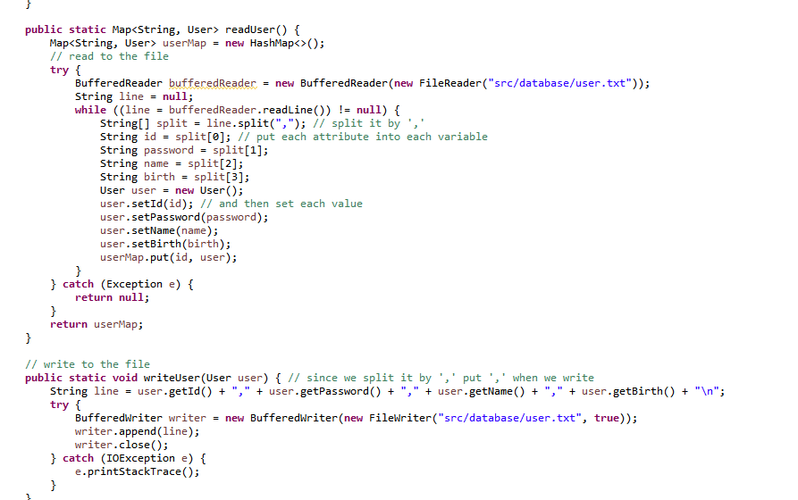

< in I/O module >

It can make read from user.txt file and write to user.txt file. We can save user information in here and read from it every time you try to login and write new member's information when you successfully sign up.

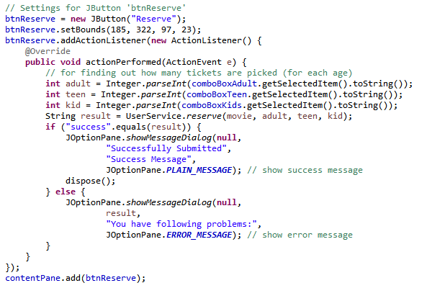

< in Reserve>

It can store the value of how many tickets are bought for each age. Also by passing movie, adult, teen, kid value as parameters of reserve method in UserService class, 'result' will give the information about whether you successfully purchase the tickets.

**5. Explain what is included in your project and why it is used (Polymorphism, Inheritance, File I/O, etc)**

Polymorphism: I created an interface named 'UserModule'. By implementing the interface in Adult, Teen class, it was made to do a different action depending on age when we reserve movie. I made a reserve method in interface and override each reserve method in Adult and Teen class so that each of them do different action depending on situation.

Inheritance: I created a class named 'User' and extend it in Adult, Teen class. By extending 'User' class, it was made for both of them(Adult class, Teen class) to use attributes in User class

File I/O: when signing up, it records the information about new member and load the user history text file whenever the program is executed.

Threads: When the program shows buy list (timelinelist) it uses threads to save memory and gives some pauses while showing the list.

**You can add more sections based on your project.**